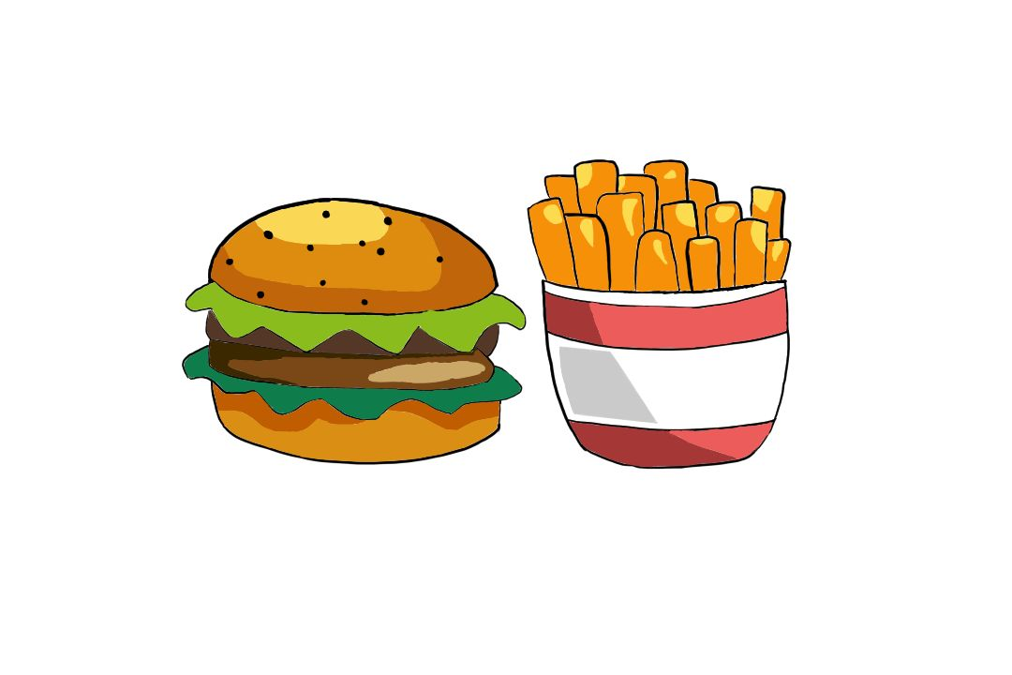THE FOOD FESTIVAL

NAME: ___________________

YEAR: ___________________

**Fill in the adjectives, do not repeat your words.**

The students of Outspoken High have planned a year full of fun activities to balance out the stressful school year. The first competition would be a cooking show. The imaginary, yet SUBLIME aroma of the food being cooked brings excitement amongst everyone in class.

Asuka, who had joined the Outspoken High students a year ago, knows how to make the best roasted chicken with vegetables. “Will you teach me how to make your signature dish?”, asks Iris. “I would be happy to help!”, exclaimed Asuka. Her English has been REMARKABLE over the past year, her first language is Japanese.

The students began to prepare their ideas for the upcoming cooking show. Jeremy had explained to the class how he was going to make a tantalizing spicy and cheesy pizza. The other students are astounded at the KICKASS idea that Jeremy had come up with, inspiring them to create their own ASTOUNDING meals.

The cooking show will take place towards the middle of the year, so students can prepare their recipes and be able to perfect and create amazing food. Excitement buzzed through the classroom, on a beautiful summer day, with a crystal blue sky and the MAJESTIC chatter of the birds , as they fly passed the school gardens. “I know we are all excited, but we have some rules for the cooking show!”, exclaimed Mrs Smith, everyone groaned but rules are very important.

“We have to consider everyone’s religions and what they cannot eat, also many students may be allergic to certain ingredients. So please label your ingredients that you have in your dishes. Many students may also be vegetarian or even vegan, please label what is friendly to these peers of yours. Wash your hands regularly too. Thank you for your co-operation!” says Mrs Smith.